## Material & Methods

### Patient Sample

This study reanalysed data from 206 right-hemispheric stroke patients, admitted to the Centre of Neurology at the University Clinic of Tübingen and whose data had been used for previous studies conducted at the Division for Neuropsychology. All patients provided their informed consent for study participation and scientific data usage. The study was conducted in accordance with the revised guidelines from the Declaration of Helsinki.

The inclusion criteria for the study were as follows:

* Imaging data must have been acquired during the acute phase of the patient’s stroke, i.e., within 14 days
* The (normalised) imaging data must have been of sufficiently high quality and revealed a demarcated lesion
* The patient suffered from no previous strokes, traumatic insults, or brain tumours
* The patient completed at least two out of the three diagnostic tests for visuospatial neglect during the acute phase after the patient’s stroke, i.e., within 14 days
  + If only two of the three tests were completed, their results must have been sufficient for a clear diagnosis, i.e., exhibiting clear symptoms/a lack of symptoms indicative of neglect in both tests

Following these criteria, the study included a total of 206 right-hemispheric stroke patients, comprised of 103 female and 103 male patients (see Table 1). The mean age at stroke was 62.6 years (SD = 13.8 years) overall, while for women it was 64.4 years (SD = 15.4 years) and 60.8 years (SD = 12.1 years) for men. 169 of the 206 patients experienced an infarct/ischaemic stroke (F = 79; M = 90), while 34 patients suffered from haemorrhagic strokes (F = 22; M = 12), and 3 patients experienced a combination of ischaemic and haemorrhagic strokes (F = 2; M = 1).

Patients were assessed for primary visual field defects (i.e., hemi- or quadrantanopia) via standard neurological confrontation testing. 32 of the included patients exhibited primary visual field defects: 26 patients (F = 14; M = 12) were diagnosed with hemianopia and 6 with quadrantanopia (F = 2; M = 4).

A total of 73 patients were diagnosed with visuospatial neglect, meaning that they exceeded the defined threshold in at least 2 out of the 3 diagnostic tests (see 2.2. Behavioural Data for details). 40 neglect patients were women, while the remaining 33 were men (see Appendix B, Supplementary Tables 1a & 1b for more detail on the clinical and demographic data for the neglect and control groups).

**Table 1:** Clinical and demographic data of the patient sample

|  |  |  |  |  |
| --- | --- | --- | --- | --- |
|  | Total  (N = 206) | Female  (N = 103) | Male  (N = 103) | p-value |
| Age *(years)* | 62.6 (14.0) [26-93] | 64.4 (15.4) [26-93] | 60.8 (12.1) [29-83] | 0.064a |
| Patient Group *(Neglect, Control)* | 73, 133 | 40, 63 | 33, 70 | 0.308b |
| Days between Stroke & Imaging | 2.9 (3.1) [0-14] | 2.8 (3.1) [0-14] | 3.1 (3.1) [0-14] | 0.580a |
| Aetiology *(Infarct, Haemorrhage, Both)* | 169, 34, 3 | 79, 22, 2 | 90, 12, 1 | 0.137b |
| Lesion volume *(cm3)* | 36.0 (44.8) [0.09-312.6] | 34.8 (44.8) [0.16-312.6] | 37.3 (43.8) [0.09-194.7] | 0.688a |
| Arterial Territory of Infarct *(ACA, MCA, PCA)* | 12, 134, 22 | 11, 61, 7 | 1, 73, 15 | **0.003b** |
| Days between Stroke & Assessment | 3.7 (2.6) [0-14] | 4.0 (2.5) [0-14] | 3.5 (2.7) [0-13] | 0.195b |
| Letter CoC | 0.16 (0.27) [-0.06-0.99] | 0.16 (0.27) [-0.02-0.99] | 0.15 (0.27) [-0.06-0.96] | 0.851a |
| Bells CoC | 0.15 (0.25) [-0.11-0.92] | 0.14 (0.23) [-0.10-0.92] | 0.17 (0.26) [-0.11-0.91] | 0.385a |
| Copying Errors  *(z-scored)* | 1.16 (1.93) [0-7] | 1.13 (1.81) [0-7] | 1.19 (2.04) [0-7] | 0.794a |
| Mean z-Score | 0.02 (0.97) [-0.75-3.04] | 0.01 (0.91) [-0.63-3.04] | 0.03 (1.02) [-0.74-2.93] | 0.833a |
| Visual field defects *(N)* | 32 | 16 | 16 | 0.849b |

Results are given as either number of patients or mean (standard deviation) [range]. The lesion volume was computed for the normalised lesion in MNI space. For the calculation of p-values, we first confirmed that the samples had equal variances. Then, either an equal variances t-test (‘a’, for continuous variables) or a Chi2 test (‘b’, for categorical variables) was calculated. p-values < 0.05 are considered significant and highlighted in bold.  
Abbreviations: *N* – Number of patients, *ACA* – Anterior Cerebral Artery, *MCA* – Medial Cerebral Artery, *PCA* – Posterior Cerebral Artery, *CoC* – Centre of Cancellation (Rorden & Karnath, 2010)

### Behavioural Data

We employed three commonly used diagnostic tests for the visuospatial neglect examination: the Letter Cancellation Task (Weintraub & Mesulam, 1985), the Bells Cancellation Test (Gauthier, Dehaut & Joanette, 1989) and a copying task (Karnath & Niemeier, 2002; see Rorden & Karnath, 2010 for an overview). The patients completed those tasks as standard paper-and-pencil tests on a horizontally oriented DIN A4 (21 x 29.7cm) sheet of paper fixated at the centre of the patient’s sagittal midline.

In the cancellation tests, patients are tasked with cancelling all target stimuli that are spatially distributed on the horizontally oriented sheet of paper. In the Letter Cancellation Task, the targets are 60 instances of the letter “A”, which are distributed among other distractor letters, while in the Bells Test the targets are bell icons distributed among other distractor symbols. Patients received no time limit for completing these tasks and were asked to confirm twice that they were content with their performance before ending the tasks.

For our analyses, we calculated the Centre of Cancellation (CoC; Rorden & Karnath, 2010) values individually for every patient. The CoC is a continuous score ranging from -1 to +1, which describes the number of missed items and their corresponding location. A score of -1 denotes a severe right-sided neglect, while a score of +1 is interpreted as severe left-sided neglect. The individual CoC values were then compared to a cut-off value (0.083 for the letter cancellation test and 0.081 for the bells cancellation test, respectively). Any value above the cut-off was seen as pathological and interpreted as a potential indicator for visuospatial neglect.

In the copying task, the number of errors made while copying a complex multi-object scene was counted. The scene comprises four items – a fence, a car, a house, and a tree – with two items each located in each half of the horizontally oriented sheet of paper. The omission of at least one contralateral feature of a given item was counted as 1 error point, while the omission of a whole item was counted as 2 error points. Additional error points were given, if the patient drew a contralateral feature or item on the ipsilesional side of the paper. If a patient scored at least 2 out of 7 possible error points, this was deemed pathological behaviour. If a patient exhibited pathological behaviour in at least 2 of the 3 tests, they were diagnosed with visuospatial neglect for the purposes of this study.

Results from all three behavioural tasks were z-scored and a mean of those scores was calculated for every patient. We calculated the z-scores based on the entire patient sample to ensure comparability between the male and female subsamples, since those groups did not differ significantly as assessed by a t-test.

### Neuroimaging Data

We used the neuroimaging data acquired during the patients’ clinical investigation at the Centre of Neurology. Since those scans were acquired for diagnostic and medical purposes, we did not have any influence on their modality or when the images were acquired. Thus, we included structural images of different modalities in this study. Out of the 206 total scans, 98 were CT scans; the remaining 108 were MR scans. On average, scans were acquired 2.9 days (SD = 3.1) after stroke (see Table 1).

If images of multiple modalities were available for a patient, MR scans were preferred. For patients with available MR scans, we preferentially used diffusion-weighted imaging (DWI) for scans acquired within the first two days after stroke onset (n = 11) and T2-weighted fluid attenuated inversion recovery (T2FLAIR) images for images acquired at a later point (n = 54). For the remaining patients (n = 43), we used a combination of two modalities (e.g., DWI and T1; see appendix B, Supplementary Table S2 for a full list).

The neuroimaging data were pre-processed using MATLAB versions R2016b and R2020a ([MathWorks](https://se.mathworks.com/products/matlab.html)), as well as the SPM12 toolbox ([Wellcome Department of Cognitive Neurology, London](https://www.fil.ion.ucl.ac.uk/spm/software/spm12/)). Generally, we followed the guidelines to lesion-behaviour mapping as described in de Haan and Karnath, 2018 and Karnath et al., 2019.

If multiple images of different modalities were available for a given patient, the corresponding images were co-registered using the SPM12 function as a first step. If only a single image was available, this step was skipped.

Then, we used the Clusterize toolbox (Clas et al., 2012; de Haan et al., 2015) to delineate each patient’s lesion semi-automatically. The toolbox’s algorithm first automatically detects potential lesions, i.e., hyper- or hypointense areas, by clustering the image according to a previously selected intensity threshold. Following Clas et al. (2012), we used a default minimum cluster size of 100 voxels. The potential lesions flagged by the algorithm are then manually reviewed, selected, and modified, resulting in a binary voxel-wise lesion map.

For patients that suffered from both a haemorrhagic stroke as well as an infarct, and as a result exhibited two lesions of different intensities (typically hyperintense for the haemorrhage and hypointense for the infarct), the Clusterize algorithm was applied separately for each intensity. Afterwards, the corresponding lesion maps were added and corrected for potential overlaps using a custom MATLAB script. Every patient’s resulting lesion map was visually inspected for its correctness by overlaying it on top of the anatomical scan using the MRIcron software (Rorden & Brett, 2000; [NITRC, 2008](https://www.nitrc.org/projects/mricron/)).

Thereafter, the Clinical toolbox (Rorden et al., 2012; [NITRC, 2014](https://www.nitrc.org/projects/clinicaltbx)) was used to normalise every patient’s anatomical scan, as well as the previously created lesion map, to MNI space (Montreal Neurological Institute; Evans et al., 1993) with the standard voxel size of 1mm3. We used this toolbox for the normalisation process rather than the standard SPM12 normalisation function, since it allowed us to normalise the scan to an age-matched template. We used enantiomorphic correction to control for the lesions during the normalisation process (cf. Karnath et al., 2019). Afterwards, we masked the extracerebral space, as well as the lateral ventricles and cerebellum to optimise the normalisation by using a custom MATLAB script. Lastly, the quality of the normalisation was manually checked for every patient’s scan by comparing the normalised brain to the template brain of the given image modality using MRIcron (Rorden & Brett, 2000).

## Data Analysis

### Lesion Analysis

We first used MRIcron (Rorden & Brett, 2000; [NITRC, 2008](https://www.nitrc.org/projects/mricron/)) to create descriptive lesion overlap and subtraction lesion plots for all relevant groups. Lesion overlap plots are topographies of all patients’ normalised lesion maps. Subtraction plots are maps that showcase which areas of the brain exhibit lesions more frequently in one patient group (typically with the cognitive deficit of interest) compared to another one (without the deficit of interest). This is done by subtracting the lesion overlap map of the patient group without the deficit from the overlap map of the group that exhibits the deficit in a voxel-wise manner (see de Haan & Karnath, 2018 for an overview). The resulting topographies were interpreted by referencing the Brainnetome atlas (Fan et al., 2016).

Subsequently, we analysed the voxel-based lesion maps using mass-univariate general linear models (GLMs) with the NiiStat toolbox ([NITRC, 2014](https://www.nitrc.org/projects/niistat/)) to identify voxels, for which damage is associated with a more severe behavioural deficit. We performed one-sided tests at p<0.05 and corrected for family-wise errors by employing 5000 permutations with maximum statistic permutation (Nichols & Holmes, 2002).

At first, we analysed it for the entire patient sample to identify damage to which voxels is generally associated with more severe symptoms. Then, we repeated the analysis separately for the female and male patient sample, to investigate if different clusters of voxels are associated with neglect severity in women and men.

### Whole-brain Disconnectivity Mapping

To identify which WM tracts were damaged by the focal stroke-induced lesions, we used the Lesion Quantification Toolkit (LQT; Griffis et al., 2021). Based on a patient’s lesion map, the LQT creates individual WM disconnectivity topographies by identifying all fibres in a given WM tract that intersect the lesioned area. To this end, we used the HCP-842 tract-wise connectome atlas, which includes 70 WM tracts and is distributed with the LQT (Yeh et al., 2018).

More specifically, the LQT embeds the binary lesion map as a region-of-interest (ROI) into the tractography atlas and filters to all fibres in a given WM tract that run through the lesioned area. These fibres are considered “disconnected streamlines”, which are then compared to the total number of fibres/streamlines of their associated WM tract to estimate how severely disconnected that WM tract is. The resulting topographies describe the percentage of disconnected fibres for every WM voxel and allow the topographical assessment of a lesion’s impact on whole-brain connectivity.

We additionally used the NiiStat toolbox ([NITRC, 2014](https://www.nitrc.org/projects/niistat/)) to investigate if damage to a specific WM tract was significantly associated with more severe behavioural deficits. As already described in Section 3.1. for the voxel-based lesion-symptom mapping, we repeated this analysis three time: for the whole patient sample, for the female patients and for the male patients, separately.

### Region-to-Region Disconnectivity

To identify which grey matter regions were disconnected from each other due to the stroke-induced WM tract damage as estimated in Section 3.2., we once again employed the LQT (Griffis et al., 2021) to create parcel-wise disconnectivity matrices for every patient. This was done by combining the HCP-842 connectome atlas (Yeh et al., 2018) with a brain parcellation atlas. We chose the Brainnetome atlas (BN-246; Fan et al., 2016) as our parcellation atlas, as it was specifically developed for connectivity analyses and includes cortical (n = 210), as well as subcortical (n = 36) regions. Following Griffis et al.’s (2021) recommendations, we defined structural connections between a parcel pair as the number of fibres that bilaterally end within the two parcels. Further, we set our binarisation threshold for the calculation of the shortest structural path lengths (SSPLs) to 50% and set the Gaussian smoothing kernel to 2. This resulted in symmetric 246-by-246 disconnectivity matrices for every patient.

In order to assess which direct disconnections between two grey matter regions are significantly associated with increased (i.e., pathological) scores in the behavioural tasks, we used custom MATLAB scripts employing mass-univariate GLMs. For this, we loaded the symmetric 246-by-246 disconnectivity matrices into MATLAB and removed the diagonal and elements below it. We also removed any ROI-to-ROI disconnections that are either (physiologically) non-existent in the patient sample or are present in less than 20% of the patient sample (All = 40; F= 20; M = 20) (cf. Herbet & Duffau, 2022; Sperber & Karnath, 2017). After removing those data, we computed a GLM for the remaining ROI-to-ROI connections, using the disconnectivity score as the independent variable and the behavioural score as the dependent variable. To correct for multiple tests, we performed one-sided tests at different statistical significance levels and corrected for family-wise errors by employing 50,000 permutations with maximum statistic permutation (Nichols & Holmes, 2002). Again, we repeated this analysis for the whole patient sample, the female patients and the male patients, separately.

Further, we repeated this analysis using a Bayesian correlation approach to confirm our findings as a Supplementary analysis (see appendix C, Supplementary analysis 1).

### Lesion-induced Increase in Shortest Structural Path Lengths (SSPLs)

The previously described analyses allow for assessing the immediate impact a focal lesion has on direct (dis-)connections between two given brain regions. However, they do not account for indirect disconnections, i.e., damaged connections that run via intermediary regions. One way of investigating such indirect disconnections is the increase in indirect shortest structural path lengths (SSPLs). The SSPL score of a parcel pair expresses how many direct connections must be traversed to establish a structural pathway between them, with parcel pairs that normally share a direct connection having a score of 1.

We used the LQT (Griffis et al., 2021) to calculate the lesion-induced increase in SSPLs relative to the provided atlases, which were the HCP-842 connectome atlas (Yeh et al., 2018) and the BN-246 parcellation atlas (Fan et al., 2016) in our case. More specifically, the LQT first computes a SSPL matrix based on the structural connectome described by the atlas as a baseline. Then, based on the previously defined binarisation threshold (i.e., 50% in our case), it calculates an individual SSPL matrix for every patient. Here, only fibre tracts/streamlines are considered that suffered less damage than the defined binarisation threshold. Finally, parcel pairs are identified that have a higher SSPL score in the patient-specific SSPL matrix than in the baseline matrix. This results in a symmetric 246-by-246 delta SSPL matrix for every patient, which includes both direct and indirect disconnections. From this, a symmetric 246-by-246 indirect SSPL matrix is created by masking out all disconnections present in the direct disconnection matrix generated in Section 3.3.

To investigate if the increase in SSPLs between two grey matter regions are significantly associated with neglect severity, we used custom MATLAB scripts to calculate Spearman correlations. As described in Section 3.3., we removed the redundant elements from the matrix, as well as all disconnections that are present in less than 20% of the patient sample. Then, we calculated a Spearman correlation using the indirect SSPL increase scores as the independent variable and the behavioural score as the dependent variable. We repeated this analysis three times – once for the whole patient sample, and then for the male and female subsamples separately.

Further, we repeated this analysis using a Bayesian correlation approach to confirm our findings as a Supplementary analysis (see appendix C, Supplementary analysis 2).

### Prediction of Patient Status

We used a supervised machine learning algorithm in the form of a nu-support vector classification (nu-SVC; Schölkopf et al., 2000 & 2001) to investigate if it would be possible to use the lesion-derived data to predict patient status in an exploratory analysis. The nu-SVC was implemented using custom scripts employing the libsvm package’s MATLAB version (Chang & Lin, 2011).

To create the instance matrix, we concatenated the voxel-wise disconnection maps of all patients, such that matrix rows comprised patients, while columns contained the associated binary status (i.e., 1 = damaged and 0 = undamaged) of all voxels. Following our previous approach, we once again excluded voxels from the analysis that were damaged in less than 5 patients. Previous research had shown that feature reduction significantly enhances model fit in lesion-deficit modelling (Kasties et al., 2021). Therefore, we used principal component analysis for dimensionality reduction: 52 components were cumulatively needed to explain 95% of the data’s variance. Thus, our resulting instance matrix had a dimension of 206-by-52. Finally, we applied mean normalisation to scale the data, such that all values were in the range between 0 and 1.

We followed the same steps for the voxel-wise lesion maps, in order to assess if disconnection maps or lesion maps held a higher predictive power. Here, 107 components were cumulatively needed to explain 95% of the variance, thus, resulting in a 206-by-107 instance matrix.

For labels, we used a numerical representation of either sex (1 = female, 2 = male), patient group (1 = neglect, 2 = control) or sex-specific patient group (1 = female neglect, 2 = male neglect, 3 = female control, 4 = male control).

We implemented the nu-SVC with a radial basis function kernel, since previous research has demonstrated that non-linear kernels improve model performance in lesion-behaviour modelling studies (Zhang et al., 2014). To improve generalisation of the model, we used a nested cross-validation (CV) approach as described and implemented by Röhrig et al. (2022). In this CV approach, the outer loop served for training the model, whereas the inner loop was utilised to optimise the hyperparameters nu and C.

More specifically, we employed a 10-fold CV for the outer loop, with almost equally sized folds. One fold was utilised as the test set, while the remaining nine folds served as the training set, which were also passed on to the inner loop. In the inner loop, we used a 5-fold CV with four folds serving as the training set and one fold as the validation set. To optimise the hyperparameters nu and C, we implemented a grid search algorithm, which trained every combination of different C and nu values, before testing their performance on the validation fold. After the inner loop, we averaged the prediction accuracy for every combination of C and nu values and selected the combination with the highest accuracy as our model. We then re-trained the outer loop model using the optimised parameters and tested the final prediction accuracy on the test set. With this approach, every patient’s status was predicted once in the outer loop. To generalise our model performance, we then repeated the model fitting procedure ten times, with different sample pseudo-randomisations. Finally, the model’s prediction accuracy was averaged across patients and loops.

## Results

### Clinical and Demographic Data

The average mean age at stroke onset was higher in women than in men (F: 64.4 ±15.4 years vs M: 60.8 ±12.1 years), exhibiting a trend towards significance at p = 0.064 (see Table 1). This finding of women being older than men are when experiencing their first stroke was also present in the neglect and control groups, though lacking significance (see Supplementary Tables 1a & 1b for details).

Overall, more women in our sample were diagnosed with neglect (n = 40; 38.8% of all women) than men were (n = 33; 32.0% of all men) – however, this difference did not reach significance (p = 0.308; see Table 1).

Women had negligibly smaller lesions (µ = 34.8 ± 44.8 cm3) than men (37.3 ± 43.8 cm3). However, this difference was non-significant at p = 0.688 (see Table 1). This trend was also present in the neglect and control groups, but the differences remained non-significant there as well (see Supplementary Tables 1a & 1b for details).

Infarct was the more common cause of stroke in our sample: 169 patients suffered from an infarct, 34 from a haemorrhage and 3 patients from a combination of both. Table 1 shows that there was a slight trend of men suffering from more infarcts (n = 90) than women (n = 79), while women were slightly more likely of experiencing haemorrhagic strokes (n = 24) than their male counterparts (n = 13).

Of the 172 patients (F = 79; M = 89) that suffered from an infarct or a combination of infarct and haemorrhage, the arterial territory that was most commonly affected was the one supplied by the medial cerebral artery (MCA): A total 73 male and 61 female patients experienced an infarct related to the MCA. The territories supplied by the anterior cerebral artery (incl. the basal ganglia; ACA) were affected by infarct in 11 female patients and 1 male patient. The posterior cerebral artery (PCA) was the focus of infarction in 7 women and 15 men.

### Voxel-based Lesion-Behaviour Mapping / Lesion Analysis

The topography of overlay plots of the patients’ acute lesions can be seen in Figure 1, while the overlay plots for the Neglect and Control groups can be found in Supplementary Figures 1a and 1b. Only voxels that have been damaged in at least 5 patients are shown, with darker/colder colours representing damage in fewer patients and brighter/warmer colours indicating damage in more patients. Visual inspection revealed that the majority of damaged voxels across all patients lays in the area of and surrounding the Insula and the Basal Ganglia. For the female subsample, the centre is found in the Basal Ganglia, while for the male subsample, it is spread out more and located between the Basal Ganglia and the Insula.

**Figure 1:** Lesion Overlay Plots

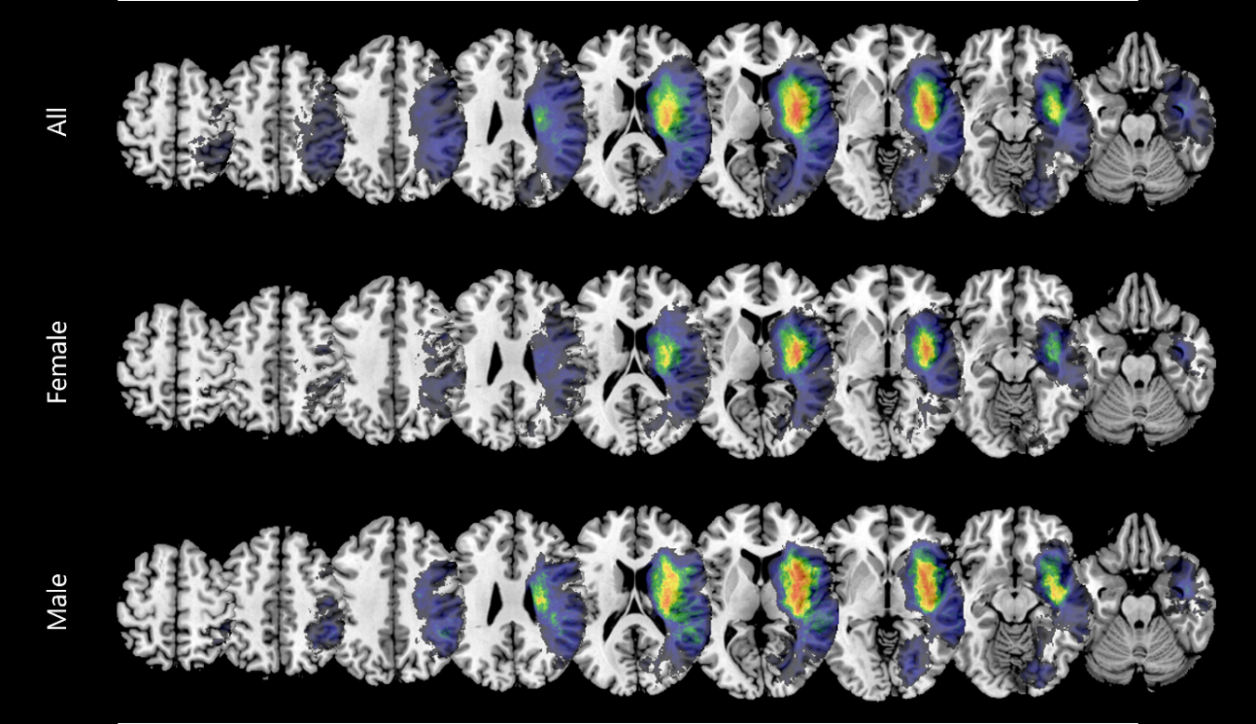

Overlaps of all normalised acute lesions included in the analyses are shown for all patients (N = 206), female and male patients (N = 103, respectively). Aggregated lesions were overlaid on an axial view of the ch2bet-template in MRIcron (Rorden & Brett, 2000). The voxels’ colours indicate the frequency of the lesion overlap and were scaled to the respective sample sizes. Only voxels damaged in at least 5 patients are depicted and were used for subsequent analyses. Colours were scaled from 5 to the maximum value of the respective patient sample. The number given above each slice refers to the z-coordinate in MNI space.

Figure 2a depicts the voxels that were damaged more frequently in one sex than the other in Subtraction Plots. The voxels that most notably were damaged more often in women were mostly clustered in the Thalamus and the Putamen and Ventral Caudate of the Basal Ganglia (BG). The voxels that were damaged more frequently in men were spread out more across the brain. Notable clusters include the Inferior Frontal Gyrus (IFG), Orbital Gyrus (OrG), Superior Temporal Gyrus (STG) and posterior STG and Medioventral Occipital Cortex (MVOcC).

When contrasting only female and male patients diagnosed with visuospatial neglect (see Figure 2b), the patterns are very similar to the ones found for the whole patient sample. The most prominent cluster of voxels damaged more frequently in women than in men is located again in the BG, but another notable cluster emerged surrounding the Middle Frontal Gyrus (MFG). Male neglect patients had more damaged voxels in the dorsal Caudate region of the Basal Ganglia, the Inferior Parietal Lobule (IPL) and STG.

**Figure 2:** Subtraction Plots

Female > Male:



Male > Female:



Neglect Female > Neglect Male:



Neglect Male > Neglect Female:



Subtraction plots of the normalised acute lesions for the (A) female and male patient sample and (B) female and male neglect patient sample, respectively. Subtraction maps were overlaid on an axial view of the ch2bet-template in MRIcron (Rorden & Brett, 2000). The voxels’ colours indicate the percentage of relative frequency difference between the patient groups. The number given above each slice refers to the z-coordinate in MNI space.

Figure 3 depicts the voxels whose damage status was significantly correlated with worse behavioural scores, as assessed via VLBM analyses using mass-univariate general linear models. Across all patients, 4232 voxels survived the correction and reached significance. The majority of those voxels is located surround the IPL, STG, the posterior Superior Temporal Sulcus (pSTS) and their associated WM fibre tracts. In the female patient subgroup, a total of 323 mostly grey matter voxels clustered around the pSTS and STG reached significance. In the male subsample, damage to a population of 273 voxels that are mainly located in WM tracts surrounding the IPL and between the STG and Middle Temporal Gyrus (MTG) were significantly associated with neglect severity.

**Figure 3:** Statistical voxel-wise lesion-behaviour mapping (VLBM) results

All:



Female:



Male:



Results of the VLBM analyses using mass-univariate GLMs to identify voxels that are significantly correlated with pathological scores in the neglect examination tests. Voxels that survived FWE correction based on permutation tests at p < 0.05 are overlaid in red on an axial view of the ch2bet-template in MRIcron (Rorden & Brett, 2000). The number given above each slice refers to the z-coordinate in MNI space.

### Whole-brain disconnectivity mapping

Figure 4 illustrates the percentage of disconnected fibres for every WM voxel across the patient sample. Disconnections are more pronounced in the right hemisphere, spanning the entire anterior-posterior-axis from the middle frontal gyrus via the orbital gyrus, basal ganglia and thalamus to the inferior temporal gyrus and finally the occipital pole. This corresponds to pronounced disconnections affecting the (inferior) occipitofrontal fasciculus and inferior longitudinal fasciculus. Further, especially the posterior segments of the corpus callosum are damaged. Disconnections also affected parts of the corticospinal tract, the uncinate fasciculus, as well as the anterior segment of the arcuate fasciculus.

**Figure 4:** Disconnection Overlay Plots



Overlaps of the whole-brain disconnections included in the analyses are shown for all patients (N = 206), female and male patients (N = 103, respectively). Aggregated disconnection maps were overlaid on an axial view of the ch2bet-template in MRIcron (Rorden & Brett, 2000). The voxels’ colours indicate the frequency of the disconnection overlap and were scaled to the respective sample sizes. Only voxels disconnected in at least 5 patients are depicted and were used for subsequent analyses. Colours were scaled from 5 to the maximum value of the respective patient sample. The number given above each slice refers to the z-coordinate in MNI space.

Comparing the disconnection overlays between the male and female subgroups, as well as the subtraction plots (see Figure 5) revealed the following differences: Women exhibited a higher percentage of disconnections in the splenium of the corpus callosum, throughout the entire cingulum, as well as the thalamus compared to men. Generally, the disconnections that occurred more frequently in women tend to follow the (inferior) occipitofrontal fasciculus, inferior longitudinal fasciculus, and corticospinal tract. In contrast to this, men generally experience more disconnections throughout the entire corpus callosum, but especially in the genu and rostrum, and in more cortical grey matter areas.

**Figure 5:** Subtraction Plots of Whole-brain Disconnectivity

Female > Male:



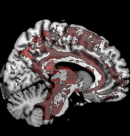 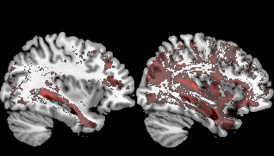 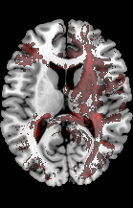

Male > Female:



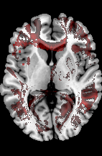 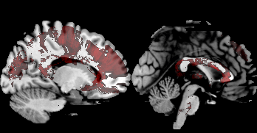 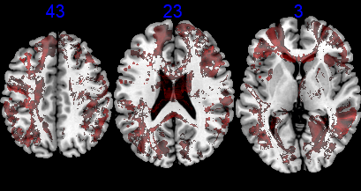

Subtraction plots of the whole-brain disconnection maps for the female and male patient sample, respectively. Subtraction maps were overlaid on the ch2bet-template in MRIcron (Rorden & Brett, 2000). The number given above each slice refers to the z-coordinate in MNI space. (A + C) The voxels’ colours indicate the percentage of relative frequency difference between the patient groups. (B + D) Selected slices showcasing anatomical structures that were damaged more frequently in one sex than the other.

The VLBM analyses we applied to identify any voxels whose disconnection status is significantly correlated with pathological behaviour yielded no significant results. No voxels survived the threshold – neither across all patients, nor for the female or male subsamples.

### Region-to-Region Disconnectivity

Using GLMs to map neglect severity to ROI-to-ROI disconnectivity, we identified a large number of significant disconnections at p = 0.05 (see Figure 6 & Table 2): Across all patients, 893 disconnections reached significance. 205 significant disconnections were identified in the female patient group and 611 disconnections were significantly correlated with pathological behaviour in the male subsample.

**Figure 6:** Significant Parcel-wise Disconnections

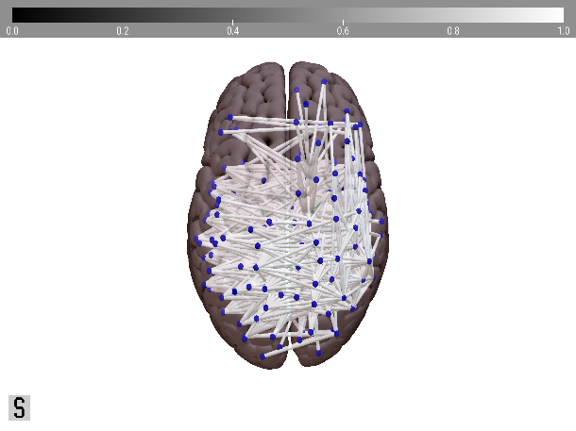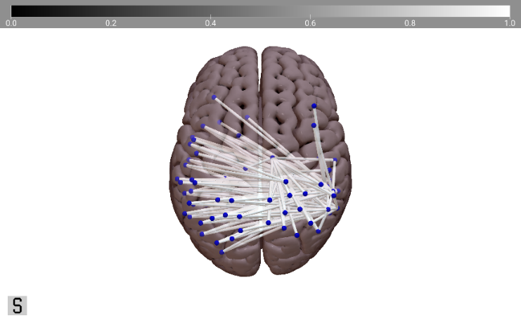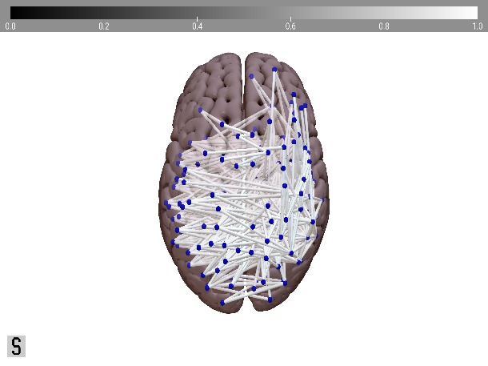

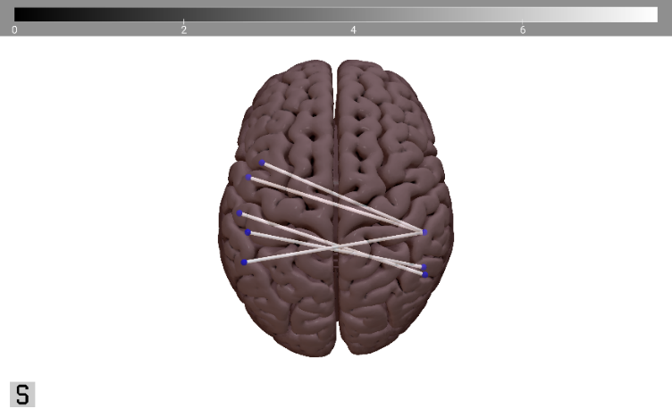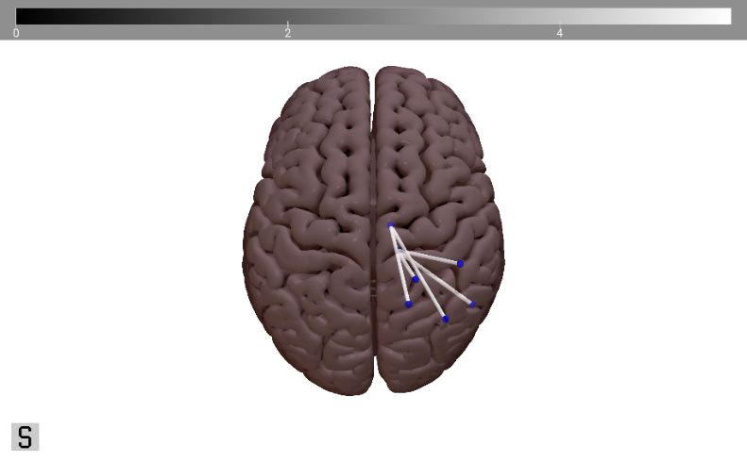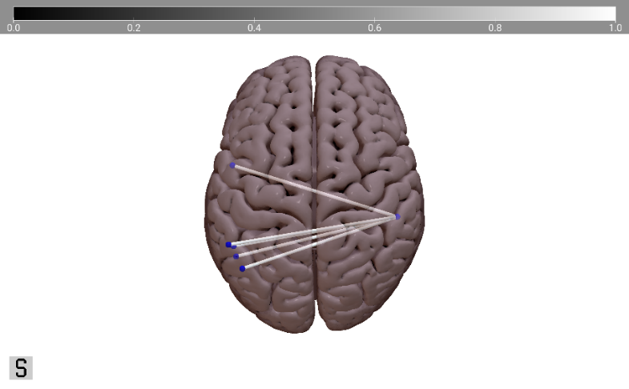

Overlaps of the significant Parcel-wise disconnections, overlaid on a superior view of the MNI152-template in SurfIce ([NITRC, 2015](https://www.nitrc.org/projects/surfice/)). (A) shows the significant disconnections at p = 0.05 for the entire patient sample (N = 893), and the female (N = 205) and male (N = 611) subsamples, respectively. (B) presents the 5 most significant disconnections (i.e., the ones with the highest T-values) for the patient (sub-)samples.

Generally, disconnections involving the IPL were the most common (see Table 2 for an overview, and Supplementary Table 3 for details): 34.8% of all disconnections across the whole patient sample had one of their endpoints in the IPL. IPL-related disconnections were also the most common disconnection in the male subsample, attributing for 30.9% of their disconnections. In the female subsample, however, the majority of disconnections (48.3%) were associated with the ITG. Here, IPL-related disconnections were the third most common (27.8%), after disconnections involving the pSTS (36.1%).

**Table 2:** Overview Significant Parcel-wise Disconnections at p = 0.05

|  |  |  |  |  |
| --- | --- | --- | --- | --- |
|  | Total  (N = 206) | Female  (N = 103) | Male  (N = 103) | p-value |
| Significant Disconnections  *(N, Ratio Inter- : Intra-hemispheric)* | 893, 607 : 286 | 205, 145 : 60 | 611, 428 : 183 | 0.853b |
| Node with highest number of sign. disconnections (Anatomical Label, % of all disconnections) | right A39rv (PGa) of IPL (5.38%) | right cpSTS  (18.54%) | right A39rv (PGa) of IPL (6.87%) |  |
| ROI with highest number of sign. disconnections (Anatomical Label, % of all disconnections) | IPL (34.8%) | ITG (48.3%) | IPL (30.9%) |  |

Selected summary statistics resulting from the parcel-wise disconnection analysis at p = 0.05. Results are either given as number of significant disconnections, number of interhemispheric disconnections : number of Intrahemispheric disconnections or as anatomical label based on BN-246 atlas (Fan et al., 2016) (contributing to percentage of disconnections). More details can be found in Appendix B, Supplementary Table 3.

In women, the five disconnections that were most significantly associated with pathological behavioural scores were all right intrahemispheric disconnections involving the thalamus, specifically the occipital and caudal temporal segments of the thalamus. In contrast to this, the five most significant disconnections in men were all interhemispheric disconnections involving the right caudoventral ITG.

In women, the disconnection that most significantly was associated with pathological behavioural scores was between the ventrolateral ITG and the occipital Thalamus of the right hemisphere.

**Table 3:** Most significant Parcel-wise disconnections

|  |  |  |  |
| --- | --- | --- | --- |
|  | Node A | Node B | T-value |
| T O T A L | left MTG  (rostral area 21) | right ITG (caudoventral area 20) | 7.5929 |
| left MTG (anterior STS) | right ITG (ventrolateral area 37) | 7.3804 |
| left STG (lateral area 38) | right ITG (caudoventral area 20) | 7.3375 |
| left IPL (rostroventral area / PFop) | right ITG (extreme lateroventral area 20) | 7.3282 |
| left IPL (caudal area 40/PFm) | right ITG (caudoventral area 20) | 7.3147 |
| F E M A L E | right ITG  (ventrolateral area 37) | right Thalamus (occipital thalamus) | 5.2566 |
| right SPL (postcentral area 7) | right Thalamus (occipital thalamus) | 5.0743 |
| right SPL (rostral area 7) | right Thalamus (caudal temporal thalamus) | 5.0445 |
| right IPL (rostrodorsal area 39 / Hip3) | right Thalamus (caudal temporal thalamus) | 4.8381 |
| right IPL (rostrodorsal area 40 / PFt) | right Thalamus (occipital thalamus) | 4.8380 |
| M A L E | left ITG (extreme lateroventral area 37) | right ITG (caudoventral area 20) | 6.6931 |
| left MTG  (rostral area 21) | right ITG (caudoventral area 20) | 6.6168 |
| left IPL (rostroventral area 39 / PGa) | right ITG (caudoventral area 20) | 6.3379 |
| left IPL (caudal area 40 / PFm) | right ITG (caudoventral area 20) | 6.3214 |
| left pSTS (caudoposterior STS) | right ITG (caudoventral area 20) | 6.3154 |

Parcel-wise disconnections with the highest T-values following the region-to-region analysis for the patient (sub-) samples. Anatomical labels are based on the BN-246 atlas (Fan et al., 2016). Abbreviations can be found in Appendix A. Intrahemispheric disconnections are highlighted in light grey. T-values were obtained from the GLM analysis, employing maximum statistic permutation at 50,000 permutations.

### Lesion-induced Increase in Shortest Structural Path Lengths (SSPLs)

We detected no significant differences in mean indirect SSPL increase between women and men. However, the increase in the maximum SSPL values yielded a significant difference between the sexes at p = 0.033 (see Table 4): The male patient subsample had an average maximum SSPL value of 3.204 (SD = 1.240) and the female subsample’s average was 3.544 (SD = 1.027).

**Table 4:** Increase in different SSPL measures across the patient sample

|  |  |  |  |  |
| --- | --- | --- | --- | --- |
|  | Total (N = 206) | Female  (N = 103) | Male  (N = 103) | p-value |
| Mean Indirect SSPL | 0.253 (0.307) [0 – 1.584] | 0.237 (0.278) [0 – 1.429] | 0.270 (0.335) [0 – 1.584] | 0.448a |
| Max Indirect SSPL | 3.374 (1.148) [0 – 6] | 3.544 (1.027) [1 – 5] | 3.204 (1.240) [0 – 6] | **0.033a** |

Results are given as mean (standard deviation) [range]. For the calculation of p-values, it was first confirmed that the samples had equal variances and then an equal variances t-test (‘a’, for continuous variables) was calculated.   
p-values < 0.05 are considered significant and highlighted in bold.

We detected no significant correlation between increase of indirect SSPLs and pathological behaviour in any of the patient (sub-)samples using the Spearman correlation approach outlined in Section 3.4. However, in a Supplementary analysis using a Bayesian correlation approach described in Appendix C, we found some indirect SSPL increases that were significantly correlated with neglect severity (see Supplementary Analysis 2).

### Prediction of Patient Status

Table 5 provides an overview of the nu-SVC prediction accuracies that were based on voxel-wise disconnection maps and lesion maps, respectively. Prediction accuracy was highest for the classification of Neglect vs Control patients at 66% for the disconnection-based and 53.4% for the lesion-based classification. Model performances were below chance level for the classification of sex, as well as sex-specific patient groups. For the Female vs Male classification, prediction accuracy was slightly higher for the model trained on lesion maps (48.5%) than for the one trained on disconnection maps (46.6%). The worst performance was achieved during the four-class classification with 32.5% prediction accuracy for the disconnection-based and 24.3% for the lesion-based model.

**Table 5:** Prediction Accuracy for Lesion-based and Disconnection-based Instance Matrices

|  |  |  |
| --- | --- | --- |
| Predicted Variable | Average Prediction Accuracy | |
| **Lesion Maps** | **Disconnection Maps** |
| Female vs Male | 48.54 % | 46.60% |
| Neglect vs Control | 53.40% | 66.02% |
| FNeg vs FCon vs MNeg vs MCon | 24.27% | 32.52% |

nu-SVC model performances as assessed by average prediction accuracy for the models trained on voxel-wise disconnection maps and lesion maps, respectively. Three versions of patient status were predicted: Sex (i.e., Female vs Male), diagnosis (i.e., Neglect vs Control) and sex-specific patient group (i.e., female neglect, female control, male neglect, male control).

## References

Allen, J. S., Damasio, H., Grabowski, T. J., Bruss, J., & Zhang, W. (2003). Sexual dimorphism and asymmetries in the gray–white composition of the human cerebrum. NeuroImage, 18(4), 880–894. <https://doi.org/10.1016/s1053-8119(03)00034-x>

Andraszewicz, S., Scheibehenne, B., Rieskamp, J., Grasman, R., Verhagen, J., & Wagenmakers, E. J. (2014). An Introduction to Bayesian Hypothesis Testing for Management Research. Journal of Management, 41(2), 521–543. <https://doi.org/10.1177/0149206314560412>

Becker, E., & Karnath, H. O. (2010). Neuroimaging of eye position reveals spatial neglect. Brain, 133(3), 909–914. <https://doi.org/10.1093/brain/awq011>

Bengtsson, H. (2018). R.matlab: Read and Write MAT Files and Call MATLAB from Within R.   
R package version 3.6.2. <https://CRAN.R-project.org/package=R.matlab>

Beschin, N., Cocchini, G., della Sala, S., & Logie, R. H. (1997). What the Eyes Perceive, The Brain Ignores: A Case of Pure Unilateral Representational Neglect. Cortex, 33(1), 3–26. <https://doi.org/10.1016/s0010-9452(97)80002-0>

Bisiach, E., & Luzzatti, C. (1978). Unilateral Neglect of Representational Space. Cortex, 14(1), 129–133. <https://doi.org/10.1016/s0010-9452(78)80016-1>

Boespflug, E. L., Storrs, J. M., Allendorfer, J. B., Lamy, M., Eliassen, J. C., & Page, S. (2011). Mean diffusivity as a potential diffusion tensor biomarker of motor rehabilitation after electrical stimulation incorporating task specific exercise in stroke: a pilot study. Brain Imaging and Behavior, 8(3), 359–369. <https://doi.org/10.1007/s11682-011-9144-1>

Bonkhoff, A. K., Schirmer, M. D., Bretzner, M., Hong, S., Regenhardt, R. W., Brudfors, M., Donahue, K. L., Nardin, M. J., Dalca, A. V., Giese, A. K., Etherton, M. R., Hancock, B. L., Mocking, S. J. T., McIntosh, E. C., Attia, J., Benavente, O. R., Bevan, S., Cole, J. W., Donatti, A., . . . Rost, N. S. (2021). Outcome after acute ischemic stroke is linked to sex-specific lesion patterns. Nature Communications, 12(1). <https://doi.org/10.1038/s41467-021-23492-3>

Bowen, A., McKenna, K., & Tallis, R. C. (1999). Reasons for Variability in the Reported Rate of Occurrence of Unilateral Spatial Neglect After Stroke. Stroke, 30(6), 1196–1202. <https://doi.org/10.1161/01.str.30.6.1196>

Broverman, I. K., Vogel, S. R., Broverman, D. M., Clarkson, F. E., & Rosenkrantz, P. S. (1972). Sex-Role Stereotypes: A Current Appraisal. Journal of Social Issues, 28(2), 59–78. <https://doi.org/10.1111/j.1540-4560.1972.tb00018.x>

Bushnell, C. D., Chaturvedi, S., Gage, K. R., Herson, P. S., Hurn, P. D., Jiménez, M. C., Kittner, S. J., Madsen, T. E., McCullough, L. D., McDermott, M., Reeves, M. J. & Rundek, T. (2018). Sex differences in stroke: Challenges and opportunities. Journal of Cerebral Blood Flow & Metabolism, 38(12), 2179–2191. <https://doi.org/10.1177/0271678x18793324>

Buxbaum, L., Ferraro, M., Veramonti, T., Farne, A., Whyte, J., Ladavas, E., Frassinetti, F., & Coslett, H. (2004). Hemispatial neglect: Subtypes, neuroanatomy, and disability. Neurology, 62(5), 749–756. <https://doi.org/10.1212/01.wnl.0000113730.73031.f4>

Catani, M. & Thiebaut De Schotten, M. (2008). A diffusion tensor imaging tractography atlas for virtual in vivo dissections. Cortex, 44(8), 1105–1132. <https://doi.org/10.1016/j.cortex.2008.05.004>

Chang, C.-C., & Lin, C.-J. (2011). LIBSVM: A library for support vector machines. ACM Transactions on Intelligent Systems and Technology, 2(3), 27:1-27:27. <https://doi.org/10.1145/1961189.1961199>

Clas, P., Groeschel, S. & Wilke, M. (2012). A Semi-Automatic Algorithm for Determining the Demyelination Load in Metachromatic Leukodystrophy. Academic Radiology, 19(1), 26–34. <https://doi.org/10.1016/j.acra.2011.09.008>

Corbetta, M. (2014). Hemispatial Neglect: Clinic, Pathogenesis, and Treatment. Seminars in Neurology, 34(05), 514–523. <https://doi.org/10.1055/s-0034-1396005>

de Haan, B., Clas, P., Juenger, H., Wilke, M., & Karnath, H. O. (2015). Fast semi-automated lesion demarcation in stroke. NeuroImage: Clinical, 9, 69–74. <https://doi.org/10.1016/j.nicl.2015.06.013>

de Haan, B., & Karnath, H. O. (2018). A hitchhiker’s guide to lesion-behaviour mapping. Neuropsychologia, 115, 5–16. <https://doi.org/10.1016/j.neuropsychologia.2017.10.021>

Evans, A., Collins, D., Mills, S., Brown, E., Kelly, R. & Peters, T. (1993). 3D statistical neuroanatomical models from 305 MRI volumes. 1993 IEEE Conference Record Nuclear Science Symposium and Medical Imaging Conference. <https://doi.org/10.1109/nssmic.1993.373602>

Fan, L., Li, H., Zhuo, J., Zhang, Y., Wang, J., Chen, L., Yang, Z., Chu, C., Xie, S., Laird, A. R., Fox, P. T., Eickhoff, S. B., Yu, C. & Jiang, T. (2016). The Human Brainnetome Atlas: A New Brain Atlas Based on Connectional Architecture. Cerebral Cortex, 26(8), 3508–3526. <https://doi.org/10.1093/cercor/bhw157>

Fee, E. (1979). Nineteenth-Century Craniology: The Study of the Female Skull. Bulletin of the History of Medicine, 53(3), 415–433. [http://www.jstor.org/sTable/44450930](http://www.jstor.org/stable/44450930)

Feigin, V. L., Forouzanfar, M. H., Krishnamurthi, R., Mensah, G. A., Connor, M., Bennett, D. A., Moran, A. E., Sacco, R. L., Anderson, L., Truelsen, T., O’Donnell, M., Venketasubramanian, N., Barker-Collo, S., Lawes, C. M. M., Wang, W., Shinohara, Y., Witt, E., Ezzati, M., Naghavi, M., & Murray, C. (2014). Global and regional burden of stroke during 1990–2010: findings from the Global Burden of Disease Study 2010. The Lancet, 383(9913), 245–255. <https://doi.org/10.1016/s0140-6736(13)61953-4>

Gauthier, L., Dehaut, F., & Joanette, Y. (1989). The Bells Test: A Quantitative and Qualitative Test for Visual Neglect. *International Journal of Clinical Neuropsychology*, *XI*(2), 49–54.

GBD 2019 Stroke Collaborators. (2021). Global, regional, and national burden of stroke and its risk factors, 1990–2019: a systematic analysis for the Global Burden of Disease Study 2019. The Lancet Neurology, 20(10), 795–820. <https://doi.org/10.1016/S1474-4422(21)00252-0>

Gibson, C. L. (2013). Cerebral Ischemic Stroke: is Gender Important? Journal of Cerebral Blood Flow & Metabolism, 33(9), 1355–1361. <https://doi.org/10.1038/jcbfm.2013.102>

Gibson, C. L., Coomber, B., & Rathbone, J. (2009). Is Progesterone a Candidate Neuroprotective Factor for Treatment following Ischemic Stroke? The Neuroscientist, 15(4), 324–332. <https://doi.org/10.1177/1073858409333069>

Goldstein, J. M., Seidman, L. M., Horton, N. J., Makris, N., Kennedy, D. N., Caviness, Jr., V. S., Faraone, S. V., & Tsuang, M. T. (2001). Normal Sexual Dimorphism of the Adult Human Brain Assessed by In Vivo Magnetic Resonance Imaging. Cerebral Cortex, 11(6), 490–497. <https://doi.org/10.1093/cercor/11.6.490>

Grabowska, A. (2016). Sex on the brain: Are gender-dependent structural and functional differences associated with behavior? Journal of Neuroscience Research, 95(1–2), 200–212. <https://doi.org/10.1002/jnr.23953>

Gray, J. (2009). Men Are from Mars, Women Are from Venus: The Classic Guide to Understanding the Opposite Sex (digital edition). HarperCollins e-books. <https://books.google.de/books?id=gOa0hfqT-M8C>

Griffis, J. C., Metcalf, N. V., Corbetta, M. & Shulman, G. L. (2020). Damage to the shortest structural paths between brain regions is associated with disruptions of resting-state functional connectivity after stroke. NeuroImage, 210, 116589. <https://doi.org/10.1016/j.neuroimage.2020.116589>

Griffis, J. C., Metcalf, N. V., Corbetta, M. & Shulman, G. L. (2021). Lesion Quantification Toolkit: A MATLAB software tool for estimating grey matter damage and white matter disconnections in patients with focal brain lesions. NeuroImage: Clinical, 30, 102639. <https://doi.org/10.1016/j.nicl.2021.102639>

Henderson, V. W., & Lobo, R. A. (2012). Hormone therapy and the risk of stroke: perspectives 10 years after the Women's Health Initiative trials. Climacteric, 15(3), 229–234. <https://doi.org/10.3109/13697137.2012.656254>

Herbet, G. & Duffau, H. (2022). Contribution of the medial eye field network to the voluntary deployment of visuospatial attention. Nature Communications, 13(1). <https://doi.org/10.1038/s41467-022-28030-3>

Hirnstein, M., Hugdahl, K., & Hausmann, M. (2019). Cognitive sex differences and hemispheric asymmetry: A critical review of 40 years of research. Laterality: Asymmetries of Body, Brain and Cognition, 24(2), 204–252. <https://doi.org/10.1080/1357650x.2018.1497044>

Hollingworth, L. S. (1918). Comparison of the sexes in mental traits. Psychological Bulletin, 15(12), 427–432. <https://doi.org/10.1037/h0075023>

Hyde, J. S. (2005). The gender similarities hypothesis. American Psychologist, 60(6), 581–592. <https://doi.org/10.1037/0003-066x.60.6.581>

Hyde, J. S. (2014). Gender Similarities and Differences. Annual Review of Psychology, 65(1), 373–398. <https://doi.org/10.1146/annurev-psych-010213-115057>

Ingalhalikar, M., Smith, A., Parker, D., Satterthwaite, T. D., Elliott, M. A., Ruparel, K., Hakonarson, H., Gur, R. E., Gur, R. C. & Verma, R. (2013). Sex differences in the structural connectome of the human brain. Proceedings of the National Academy of Sciences, 111(2), 823–828. <https://doi.org/10.1073/pnas.1316909110>

Jackson, D., Kirkbride, J., Croudace, T., Morgan, C., Boydell, J., Errazuriz, A., Murray, R. M. & Jones, P. B. (2013). Meta‐analytic approaches to determine gender differences in the age‐incidence characteristics of schizophrenia and related psychoses. International Journal of Methods in Psychiatric Research, 22(1), 36–45. <https://doi.org/10.1002/mpr.1376>

Jarosz, A. F., & Wiley, J. (2014). What Are the Odds? A Practical Guide to Computing and Reporting Bayes Factors. The Journal of Problem Solving, 7(1). <https://doi.org/10.7771/1932-6246.1167>

Jensen, A., Castro, A. W., Ferretti, M. T., Martinkova, J., Vasilevskaya, A., Santuccione Chadha, A. & Tartaglia, A. C. (2022). Sex and gender differences in the neurological and neuropsychiatric symptoms of long COVID: A narrative review. The Italian Journal of Gender-Specific Medicine, 8(1), 18–28. <https://doi.org/10.1723/3769.37563>

Kanaan, R. A., Allin, M., Picchioni, M., Barker, G. J., Daly, E., Shergill, S. S., Woolley, J., & McGuire, P. K. (2012). Gender Differences in White Matter Microstructure. PLoS ONE, 7(6), e38272. <https://doi.org/10.1371/journal.pone.0038272>

Karnath, H. O. (2015). Spatial attention systems in spatial neglect. Neuropsychologia, 75, 61–73. <https://doi.org/10.1016/j.neuropsychologia.2015.05.019>

Karnath, H. O., & Dieterich, M. (2006). Spatial neglect—a vestibular disorder? Brain, 129(2), 293–305. <https://doi.org/10.1093/brain/awh698>

Karnath, H. O., & Niemeier, M. (2002). Task-dependent differences in the exploratory behaviour of patients with spatial neglect. Neuropsychologia, 40(9), 1577–1585. <https://doi.org/10.1016/s0028-3932(02)00020-9>

Karnath, H. O., & Rorden, C. (2012). The anatomy of spatial neglect. Neuropsychologia, 50(6), 1010–1017. <https://doi.org/10.1016/j.neuropsychologia.2011.06.027>

Karnath, H. O., Sperber, C., Wiesen, D., & de Haan, B. (2019). Lesion-Behavior Mapping in Cognitive Neuroscience: A Practical Guide to Univariate and Multivariate Approaches. Spatial Learning and Attention Guidance, 209–238. <https://doi.org/10.1007/7657_2019_18>

Kasties, V., Karnath, H. & Sperber, C. (2021). Strategies for feature extraction from structural brain imaging in lesion‐deficit modelling. Human Brain Mapping, 42(16), 5409–5422. <https://doi.org/10.1002/hbm.25629>

Katan, M., & Luft, A. (2018). Global Burden of Stroke. Seminars in Neurology, 38(02), 208–211. <https://doi.org/10.1055/s-0038-1649503>

Kovalev, V. A., Kruggel, F. & von Cramon, D. (2003). Gender and age effects in structural brain asymmetry as measured by MRI texture analysis. NeuroImage, 19(3), 895–905. <https://doi.org/10.1016/s1053-8119(03)00140-x>

Li, K., & Malhotra, P. A. (2015). Spatial neglect. Practical Neurology, 15(5), 333–339. <https://doi.org/10.1136/practneurol-2015-001115>

Li, H., Pin, S., Zeng, Z., Wang, M. M., Andreasson, K. A., & McCullough, L. D. (2005). Sex differences in cell death. Annals of Neurology, 58(2), 317–321. <https://doi.org/10.1002/ana.20538>

Liu, M., Kelley, M. H., Herson, P. S., & Hurn, P. D. (2010). Neuroprotection of Sex Steroids. Minerva Endocrinologica, 35(2), 127–143.

Liu, M., Oyarzabal, E. A., Yang, R., Murphy, S. J., & Hurn, P. D. (2008). A novel method for assessing sex-specific and genotype-specific response to injury in astrocyte culture. Journal of Neuroscience Methods, 171(2), 214–217. <https://doi.org/10.1016/j.jneumeth.2008.03.002>

Liu, R., & Yang, S.-H. (2013). Window of opportunity: Estrogen as a treatment for ischemic stroke. Brain Research, 1514, 83–90. <https://doi.org/10.1016/j.brainres.2013.01.023>

Manwani, B., Bentivegna, K., Benashski, S. E., Venna, V. R., Xu, Y., Arnold, A. P., & McCullough, L. D. (2014). Sex Differences in Ischemic Stroke Sensitivity Are Influenced by Gonadal Hormones, Not by Sex Chromosome Complement. Journal of Cerebral Blood Flow & Metabolism, 35(2), 221–229. <https://doi.org/10.1038/jcbfm.2014.186>

Nichols, T. E. & Holmes, A. P. (2002). Nonparametric permutation tests for functional neuroimaging: A primer with examples. Human Brain Mapping, 15(1), 1–25. <https://doi.org/10.1002/hbm.1058>

Nuzzo, R. L. (2017). An Introduction to Bayesian Data Analysis for Correlations. PM&R, 9(12), 1278–1282. <https://doi.org/10.1016/j.pmrj.2017.11.003>

R Core Team (2018). R: A language and environment for statistical computing. R Foundation for Statistical Computing, Vienna, Austria. URL <https://www.R-project.org/>

Röhrig, L., Sperber, C., Bonilha, L., Rorden, C. & Karnath, H. O. (2022). Right hemispheric white matter hyperintensities improve the prediction of spatial neglect severity in acute stroke. medRxiv. <https://doi.org/10.1101/2022.04.08.22273547>

Rorden, C., Bonilha, L., Fridriksson, J., Bender, B., & Karnath, H. O. (2012). Age-specific CT and MRI templates for spatial normalization. NeuroImage, 61(4), 957–965. <https://doi.org/10.1016/j.neuroimage.2012.03.020>

Rorden, C., & Brett, M. (2000). Stereotaxic Display of Brain Lesions. Behavioural Neurology, 12(4), 191–200. <https://doi.org/10.1155/2000/421719>

Rorden, C., & Karnath, H. O. (2010). A simple measure of neglect severity. *Neuropsychologia*, *48*(9), 2758–2763. <https://doi.org/10.1016/j.neuropsychologia.2010.04.018>

Schölkopf, B., Platt, J. C., Shawe-Taylor, J., Smola, A. J. & Williamson, R. C. (2001). Estimating the Support of a High-Dimensional Distribution. Neural Computation, 13(7), 1443–1471. <https://doi.org/10.1162/089976601750264965>

Schölkopf, B., Smola, A. J., Williamson, R. C. & Bartlett, P. L. (2000). New Support Vector Algorithms. Neural Computation, 12(5), 1207–1245. <https://doi.org/10.1162/089976600300015565>

Sherman, J. A. (1967). Problem of sex differences in space perception and aspects of intellectual functioning. Psychological Review, 74(4), 290–299. <https://doi.org/10.1037/h0024723>

Shields, S. (1975). Functionalism, Darwinism, and the psychology of women. American Psychologist, 30(7), 739–754. <https://doi.org/10.1037/h0076948>

Snyder, H. M., Asthana, S., Bain, L., Brinton, R., Craft, S., Dubal, D. B., Espeland, M. A., Gatz, M., Mielke, M. M., Raber, J., Rapp, P. R., Yaffe, K. & Carrillo, M. C. (2016). Sex biology contributions to vulnerability to Alzheimer’s disease: A think tank convened by the Women’s Alzheimer’s Research Initiative. Alzheimer’s & Dementia, 12(11), 1186–1196. <https://doi.org/10.1016/j.jalz.2016.08.004>

Sperber, C. & Karnath, H. O. (2017). Impact of correction factors in human brain lesion-behavior inference. Human Brain Mapping, 38(3), 1692–1701. <https://doi.org/10.1002/hbm.23490>

Stone, S. P., Halligan, P. W., & Greenwood, R. J. (1993). The Incidence of Neglect Phenomena and Related Disorders in Patients with an Acute Right or Left Hemisphere Stroke. Age and Ageing, 22(1), 46–52. <https://doi.org/10.1093/ageing/22.1.46>

Suzuki, S., Brown, C. M., & Wise, P. M. (2009). Neuroprotective effects of estrogens following ischemic stroke. Frontiers in Neuroendocrinology, 30(2), 201–211. <https://doi.org/10.1016/j.yfrne.2009.04.007>

Ten Brink, A. F., Verwer, J. H., Biesbroek, J. M., Visser-Meily, J. M. A., & Nijboer, T. C. W. (2016). Differences between left- and right-sided neglect revisited: A large cohort study across multiple domains. Journal of Clinical and Experimental Neuropsychology, 39(7), 707–723. <https://doi.org/10.1080/13803395.2016.1262333>

Voyer, D., Voyer, S. D. & Saint-Aubin, J. (2016). Sex differences in visual-spatial working memory: A meta-analysis. Psychonomic Bulletin & Review, 24(2), 307–334. <https://doi.org/10.3758/s13423-016-1085-7>

Weintraub, S., & Mesulam, M. M. (1985). Mental state assessment of the young and elderly adults in behavioral neurology. In M. M. Mesulam (Ed.), Principles of Behavioral Neurology (pp. 71–123). Philadelphia, PA: FA Davis

Wickham, H., François, R., Henry, L. & Müller, K. (2019). dplyr: A Grammar of Data Manipulation. R package version 0.8.0.1. <https://CRAN.R-project.org/package=dplyr>

Wickham, H. & Henry, L. (2019). tidyr: Easily Tidy Data with 'spread()' and 'gather()' Functions. R package version 0.8.3. <https://CRAN.R-project.org/package=tidyr>

Wise, P. M., Dubal, D. B., Wilson, M. E., Rau, S. W., Böttner, M., & Rosewell, K. L. (2001). Estradiol is a protective factor in the adult and aging brain: understanding of mechanisms derived from in vivo and in vitro studies. Brain Research Reviews, 37(1-3), 313–319. <https://doi.org/10.1016/s0165-0173(01)00136-9>

Wittig, M. A. (1976). Sex differences in intellectual functioning: How much of a difference do genes make? Sex Roles, 2(1), 63–74. <https://doi.org/10.1007/bf00289299>

Woolley, H. T. (1914). The psychology of sex. Psychological Bulletin, 11(10), 353–379. <https://doi.org/10.1037/h0070064>

Yeh, F. C., Panesar, S., Fernandes, D., Meola, A., Yoshino, M., Fernandez-Miranda, J. C., Vettel, J. M. & Verstynen, T. (2018). Population-averaged atlas of the macroscale human structural connectome and its network topology. NeuroImage, 178, 57–68. <https://doi.org/10.1016/j.neuroimage.2018.05.027>

Zasler, N. D., & Kaplan, P. E. (2017). Fractional Anisotropy. Encyclopedia of Clinical Neuropsychology, 1. <https://doi.org/10.1007/978-3-319-56782-2_32-2>

Zell, E., Krizan, Z., & Teeter, S. R. (2015). Evaluating gender similarities and differences using metasynthesis. American Psychologist, 70(1), 10–20. <https://doi.org/10.1037/a0038208>

Zhang, Y., Kimberg, D. Y., Coslett, H. B., Schwartz, M. F. & Wang, Z. (2014). Multivariate lesion-symptom mapping using support vector regression. Human Brain Mapping, 35(12), 5861–5876. <https://doi.org/10.1002/hbm.22590>

## Data Usage Statement

To the largest part, custom MATLAB scripts were used for data analysis that were written by Tamara Keßler. In some instances, however, openly available scripts published by other researchers were used:

Röhrig, L. (2022). Dataset for: Right hemispheric white matter hyperintensities improve the prediction of spatial neglect severity in acute stroke. Mendeley Data, V1, DOI: [10.17632/c8n42jz525.1](https://data.mendeley.com/datasets/c8n42jz525/1)

Smaczny, S. (2022). Left angular gyrus disconnection impairs multiplication fact retrieval, descriptive data and scripts. Mendeley Data, V2, DOI: [10.17632/yjkr647mzb.2](https://data.mendeley.com/datasets/yjkr647mzb/2)

Sperber, C. (2022). Scripts and tutorials for indirect structural disconnection-symptom mapping by Sperber, Griffis & Kasties. Mendeley Data, V2, DOI: [10.17632/hdzptzz8r5.2](https://data.mendeley.com/datasets/hdzptzz8r5)

## Appendix

### Appendix A: List of Abbreviations

|  |  |
| --- | --- |
| ACA | Anterior Cerebral Artery |
| CoC | Centre of Cancellation |
| CT | Computed Tomography |
| CV | Cross Validation |
| DTI | Diffusion Tensor Imaging |
| DWI | Diffusion-weighted Imaging |
| FA | Functional Anisotropy |
| GLM | Generalised Linear Model |
| HCP | Human Connectome Project |
| IOF | Inferior Occipitofrontal Fasciculus |
| IPL | Inferior Parietal Lobule |
| ITG | Inferior Temporal Gyrus |
| LQT | Lesion Quantification Toolkit |
| MCA | Medial Cerebral Artery |
| MD | Mean Diffusivity |
| MNI | Montreal Neurological Institute |
| MRI | Magnetic Resonance Imaging |
| MTG | Middle Temporal Gyrus |
| nu-SVC | nu-Support Vector Classification |
| PCA | Posterior Cerebral Artery |
| pSTS | Posterior Superior Temporal Sulcus |
| ROI | Region Of Interest |
| SLF | Superior Longitudinal Fasciculus |
| SOF | Superior Occipitofrontal Fascicle |
| SPL | Superior Parietal Lobule |
| SSPL | Shortest Structural Path Length |
| STG | Superior Temporal Gyrus |
| STS | Superior Temporal Sulcus |
| T2FLAIR | T2-weighted Fluid Attenuated Inversion Recovery |
| TPJ | Temporo-Parietal Junction |
| VLBM | Voxel-based Lesion-Behaviour Mapping |
| vlPFC | Ventrolateral Prefrontal Cortex |
| WM | White Matter |

### Appendix B: Supplementary Tables and Figures

**Supplementary Table 1a:** Clinical and Demographic Data of Neglect Patients

|  |  |  |  |  |
| --- | --- | --- | --- | --- |
|  | Total  (N = 73) | Female  (N = 40) | Male  (N = 33) | p-value |
| Age *(years)* | 65.1 (13.9) [29-93] | 67.5 (14.3) [34-93] | 62.3 (12.8) [29-81] | 0.114a |
| Days between Stroke & Imaging | 3.4 (3.5) [0-14] | 3.4 (3.6) [0-14] | 3.4 (3.4) [0-14] | 0.971a |
| Aetiology *(Infarct, Haemorrhage, Both)* | 55, 15, 3 | 28, 10, 2 | 27, 5, 1 | 0.507b |
| Lesion volume *(cm3)* | 63.8 (44.8) [0.37-312.6] | 58.2 (62.3) [0.09-312.6] | 70.0 (51.6) [0.37-194.7] | 0.416a |
| Arterial Territory of Infarct *(ACA, MCA, PCA)* |  |  |  |  |
| Days between Stroke & Assessment | 4.0 (2.9) [0-14] | 4.0 (2.9) [0-14] | 3.8 (2.8) [0-13] | 0.709a |
| Letter CoC | 0.42 (0.31) [-0.02-0.99] | 0.39 (0.31) [-0.02-0.99] | 0.44 (0.30) [-0.001-0.96] | 0.487a |
| Bells CoC | 0.39 (0.28) [-0.1-0.92] | 0.33 (0.28) [-0.1-0.92] | 0.46 (0.27) [0-0.91] | 0.058a |
| Copying Errors | 2.93 (2.31) [0-7] | 2.67 (2.21) [0-7] | 3.34 (2.35) [0-7] | 0.132a |
| Mean z-Score | 0.97 (1.05) [-0.6-3.04] | 0.80 (1.03) [-0.45-3.04] | 1.19 (1.03) [-0.6-2.93] | 0.116a |
| Visual field defects *(N)* | 17 | 9 | 8 | 0.940b |

**Supplementary Table 1b:** Clinical and Demographic Data of Control Patients

|  |  |  |  |  |
| --- | --- | --- | --- | --- |
|  | Total  (N = 133) | Female  (N = 63) | Male  (N = 70) | p-value |
| Age *(years)* | 61.2 (13.9) [26-88] | 62.4 (15.8) [26-88] | 60.1 (11.7) [36-83] | 0.328a |
| Days between Stroke & Imaging | 2.7 (2.9) [0-11] | 2.4 (2.7) [0-11] | 2.9 (3.0) [0-11] |  |
| Aetiology *(Infarct, Haemorrhage, Both)* | 114, 19, 0 | 51, 12, 0 | 63, 7, 0 |  |
| Lesion volume *(cm3)* | 20.8 (24.7) [0.09-138.1] | 19.6 (19.2) [0.16-70.5] | 21.7 (28.7) [0.09-138.1] | 0.595a |
| Arterial Territory of Infarct *(ACA, MCA, PCA)* |  |  |  |  |
| Days between Stroke & Assessment | 2.6 (2.6) [0-12] | 3.9 (2.3) [1-9] | 3.3 (3.0) [0-12] |  |
| Letter CoC | 0.02 (0.07) [-0.06-0.78] | 0.02 (0.02) [-0.02-0.08] | 0.02 (0.10) [-0.06-0.80] |  |
| Bells CoC | 0.03 (0.09) [-0.11-0.83] | 0.03 (0.05) [-0.04-0.26] | 0.03 (0.11) [-0.11-0.83] |  |
| Copying Errors | 0.22 (0.58) [0-4] | 0.27 (0.65) [0-4] | 0.16 (0.51) [0-3] |  |
| Mean z-Score | -0.5 (0.25) [-0.75-1.99] | -0.5 (0.14) [-0.64-0.09] | -0.51 (0.32) [-0.75-1.99] |  |
| Visual field defects *(N)* | 15 | 7 | 8 |  |

Results are given as either number of patients or mean (standard deviation) [range]. The lesion volume was computed for the normalised lesion in MNI space. For the calculation of p-values, it was first confirmed that the samples had equal variances and then either an equal variances t-test (‘a’, for continuous variables) or a Chi2 test (‘b’, for categorical variables) was calculated. p-values < 0.05 are considered significant and highlighted in bold.  
Abbreviations: *N* – Number of patients, *ACA* – Anterior Cerebral Artery, *MCA* – Medial Cerebral Artery, *PCA* – Posterior Cerebral Artery, *CoC* – Centre of Cancellation (Rorden & Karnath, 2010)

**Supplementary Table 2:** Used Scan Modalities for all patients

|  |  |  |  |
| --- | --- | --- | --- |
|  | Total  (N = 206) | Female  (N = 103) | Male  (N = 103) |
| CT | 98 | 57 | 41 |
| T2FLAIR | 54 | 24 | 30 |
| T2FLAIR + T1 | 11 | 4 | 7 |
| DWI | 18 | 8 | 10 |
| DWI + T1 | 19 | 8 | 11 |
| DWI + T2FLAIR | 6 | 2 | 4 |

Results are given as number of patients. MR scans were preferred over CT scans, if both modalities were available. In patients with multiple MR modalities, we preferentially used DWI if the images were acquired less than 48 hours after stroke and T2FLAIR for images that were acquired later. Abbreviations: See Appendix A.

**Supplementary Table 3**: Number of significant disconnections per Region at p = 0.05

|  |  |  |  |  |  |  |  |  |  |  |  |  |  |
| --- | --- | --- | --- | --- | --- | --- | --- | --- | --- | --- | --- | --- | --- |
|  | Total  (N = 893) | | Female  (N = 205) | | | | | Male (N = 611) | | | p-value | | |
| Amygdala (Amyg) | 12 | (1.34%) | 0 | (0.00%) | | 7 | | | (1.14%) | | |  | | |
| Basal Ganglia (BG) | 60 | (6.72%) | 2 | (0.96%) | | 37 | | | (6.06%) | | |  | | |
| Fusiform Gyrus (FuG) | 24 | (2.69%) | 1 | (0.49%) | | 18 | | | (2.94%) | | |  | | |
| Hippocampus (Hipp) | 27 | (3.02%) | 3 | (1.46%) | | 13 | | | (2.13%) | | |  | | |
| Inferior Frontal Gyrus (IFG) | 12 | (1.34%) | 0 | (0.00%) | | 4 | | | (0.65%) | | |  | | |
| Insula (Ins) | 8 | (0.89%) | 0 | (0.00%) | | 9 | | | (1.47%) | | |  | | |
| Inferior Parietal Lobule (IPL) | 311 | (34.83%) | 57 | (27.80%) | | 189 | | | (30.93%) | | |  | | |
| Inferior Temporal Gyrus (ITG) | 286 | (32.03%) | 99 | (48.29%) | | 261 | | | (42.72%) | | |  | | |
| Lateral Occipital Cortex (LOcC) | 93 | (10.41%) | 9 | (4.39%) | | 80 | | | (13.09%) | | |  | | |
| Middle Frontal Gyrus (MFG) | 31 | (3.47%) | 3 | (1.46%) | | 23 | | | (3.76%) | | |  | | |
| Middle Temporal Gyrus (MTG) | 174 | (19.48%) | 45 | (21.95%) | | 160 | | | (26.19%) | | |  | | |
| Medioventral Occipital Cortex (MVOcC) | 15 | (1.68%) | 0 | (0.00%) | | 12 | | | (1.96%) | | |  | | |
| Orbital Gyrus (Org) | 15 | (1.68%) | 2 | (0.96%) | | 19 | | | (3.11%) | | |  | | |
| Paracentral Lobule (PCL) | 4 | (0.45%) | 0 | (0.00%) | | 0 | | | (0.00%) | | |  | | |
| Precuneus (Pcun) | 33 | (3.70%) | 6 | (2.93%) | | 19 | | | (3.11%) | | |  | | |
| Parahippocampal Gyrus (PhG) | 3 | (0.34%) | 0 | | (0.00%) | | 5 | | | (0.82%) | | |  | | |
| Postcentral Gyrus (PoG) | 59 | (6.61%) | 3 | | (1.46%) | | 25 | | | (4.89%) | | |  | | |
| Precentral Gyrus (PrG) | 33 | (3.70%) | 2 | | (0.96%) | | 24 | | | (3.93%) | | |  | | |
| Posterior Superior Parietal Sulcus (pSTS) | 107 | (11.98%) | 74 | | (36.10%) | | 33 | | | (5.40%) | | |  | | |
| Superior Frontal Gyrus (SFG) | 17 | (1.90%) | 0 | | (0.00%) | | 14 | | | (2.29%) | | |  | | |
| Superior Parietal Lobule (SPL) | 151 | (16.91%) | 35 | | (17.07%) | | 91 | | | (14.89%) | | |  | | |
| Superior Temporal Gyrus (STG) | 156 | (17.47%) | 18 | | (8.78%) | | 118 | | | (19.31%) | | |  | | |
| Thalamus (Tha) | 155 | (17.36%) | 51 | | (24.88%) | | 61 | | | (9.98%) | | |  | | |

Results are given as number of significant disconnections associated with this region (percentage relative to total number of disconnections). Regions and their abbreviations are based on the BN-246 atlas (Fan et al., 2016). It is important to note that these percentages add up to 200% – this is because there are always 2 nodes/regions involved in a disconnection. Thus, there are twice as many disconnected nodes as there are disconnections.

**Supplementary Figure 1a:** Lesion Overlay Plots for Neglect Patients

All Neglect:

Ein Bild, das Text, Keramikwaren, Zahnrad enthält.

Female Neglect:

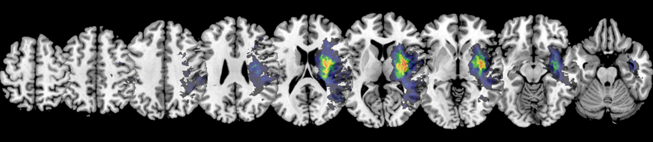

Male Neglect:

Ein Bild, das Text, Primat, Säugetier enthält.

**Supplementary Figure 1b:** Lesion Overlay Plots for Control Patients

All Control:

Ein Bild, das Text, Rad, Zahnrad enthält.

Female Control:

Ein Bild, das Text, Zahnrad enthält.

Male Control:

Ein Bild, das Text enthält.

**Supplementary Figure 2:** Significant Parcel-wise Disconnections resulting from Bayesian Correlation

All:

Ein Bild, das Text, orange enthält.

Female:

Ein Bild, das orange, Molluske, dunkel enthält.

Male:

Ein Bild, das Text, Molluske, orange enthält.

**Supplementary Figure 3:** Significant increases in indirect SSPLs resulting from Bayesian Correlation

All:

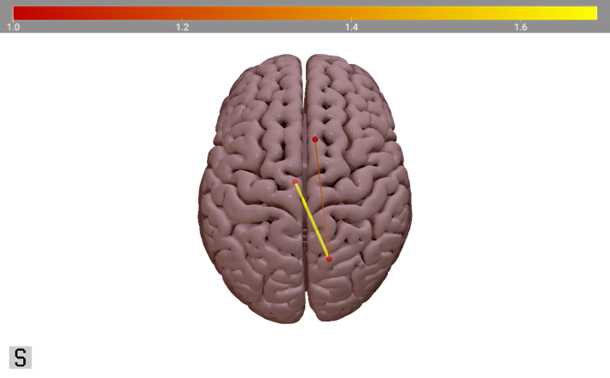

Female:



Male:

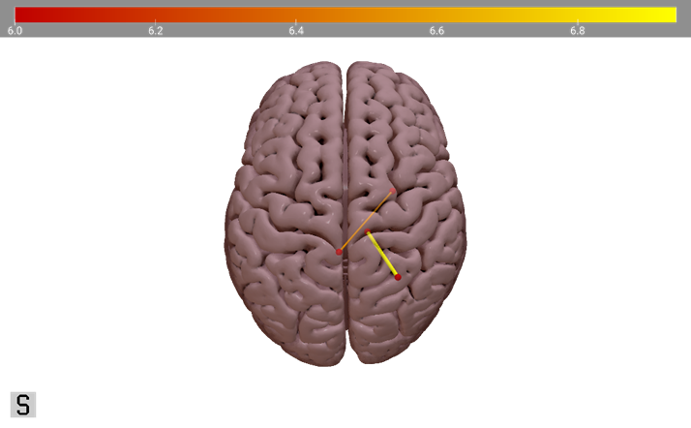

### Appendix C: Supplementary Analyses

**Supplementary Analysis 1:** Bayesian Correlation for Region-to-Region Disconnectivity

In order to assess which direct disconnections between two grey matter regions are significantly associated with increased neglect severity, we used custom R (R Core Team, 2018) scripts to calculate Bayesian correlations (for an overview see Nuzzo, 2017). For this, we used the R.matlab (Bengtsson, 2018), tidyr (Wickham & Henry, 2019) and dplyr (Wickham et al., 2019) packages.

First, we loaded the symmetric 246-by-246 disconnectivity matrices into R and removed the diagonal and elements below it. We also removed any ROI-to-ROI disconnections that are either (physiologically) non-existent in the patient sample or are present in less than 20% of the patient sample (All = 40; F = 20; M = 20) (cf. Herbet & Duffau, 2022; Sperber & Karnath, 2017). After removing those data, we computed a Bayesian correlation for the remaining ROI-to-ROI connections, using the disconnectivity score as the independent variable and the behavioural score as the dependent variable. Again, we repeated this analysis for the whole patient sample, the female patients, and the male patients, separately.

We found the same patterns of significant parcel-wise disconnections as described in Section 4.4., providing moderate to strong evidence in favour of our hypothesis as assessed via Bayes Factors (see Supplementary Figure 2; cf. Andraszewicz et al., 2014; Jarosz & Wiley, 2014).

[more details needed 🡪 most significant disconnections + associated bayes factor; similar to table 3]

**Supplementary Analysis 2:** Bayesian Correlation for Increase of Indirect SSPLs

To investigate if the increase in SSPLs between two grey matter regions are significantly associated with pathological behavioural scores, we used custom R (R Core Team, 2018) scripts employing the R.matlab (Bengtsson, 2018), tidyr (Wickham & Henry, 2019) and dplyr (Wickham et al., 2019) packages.

As described in Section 3.3. and Supplementary Analysis 1, we removed the redundant elements from the matrix, as well as all disconnections that are present in less than 20% of the patient sample. Then, we calculated a Bayesian correlation between the behavioural data and the SSPL values across the patient (sub-)samples. We repeated this analysis three times – once for the whole patient sample, and then for the male and female subsamples separately.

Using this Bayesian approach, we detected some significant indirect SSPL increases where the frequentist analysis did not find any as described in Section 4.5. Those significant SSPL increases are shown in Supplementary Figure 3.

[more details needed 🡪 most significant SSPL increases + associated bayes factor; similar to table 3]